# Exercise 1 – Set up an AWS Account

Go to aws.amazon.com and sign up for a free account. If it asks what type of account you are wanting to work with, choose the ‘Personal’ option.

You’ll need to enter your card details for your account as well as your phone number for verification. The exercises won’t require any payment on your card as we’re working with free-tier tools, so don’t worry about this; it’s simply a requirement.

After this is done, you should be able to view AWS’ management console. Ensure that the region in the top right is Ireland (EU west). The console should look something like this:

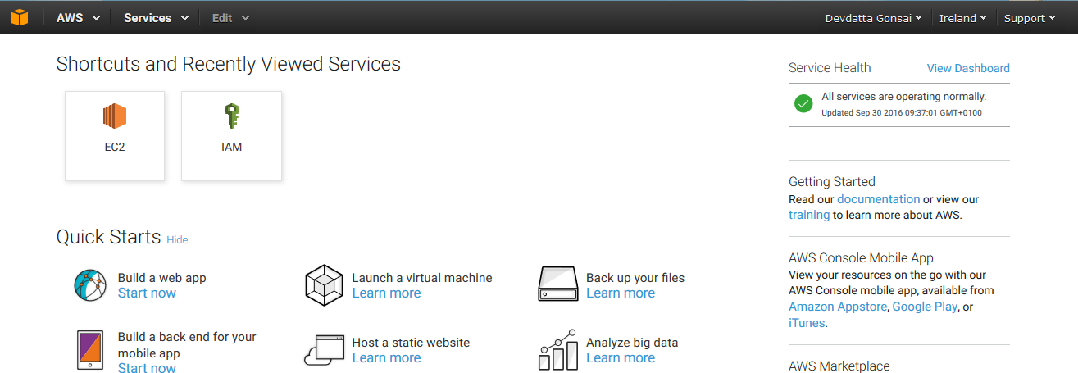

# Exercise 2 – IAM

Navigate to the IAM and create 4-5 users. This is done through a simple set of text boxes, so it shouldn’t take too long. After this is done, make 2 groups and add half of your users into each group. Name your groups something unique – e.g. [your initials]-Group1.

After this is done, navigate to the Policy section of the IAM and create a new policy based on a pre-existing AWS policy. Search and add the ReadOnlyAccess and create your policy. Give it a meaningful name and description so you can refer to it in the future.

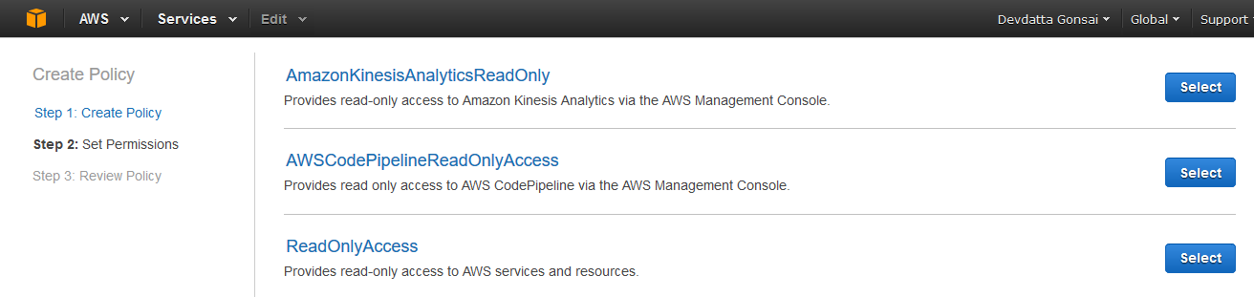

Make note of the script found before confirming your policy and answer the following:

* What language is this written in?
* How could you further customise it?
* Describe some of the elements found within the script

# Exercise 3 – EC2

Navigate to Amazon EC2 and explore the UI.

Before we launch any machines through AWS, we need to create a key pair. Go to Network & Security > Key Pairs and create a new Key Pair. Again, name it something meaningful such as [your initials]-puppet. After confirming, you have to download the key pair. Make sure you don’t delete this! It should look something like this in the console:

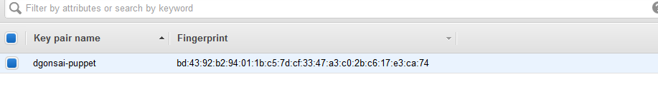

You should find an option to Launch Instances; pick this. From here, you are to launch 3 instances with the following specifications:

* AMI: Ubuntu Server 14.04 LTS (HVM), SSD Volume Type - ami-ed82e39e
* Instance Type: t2.micro (free tier eligible)
* Number of instances: 3
* Storage: 8 GiB
* Do not add a tag
* Security group: replicate the following…  
    
  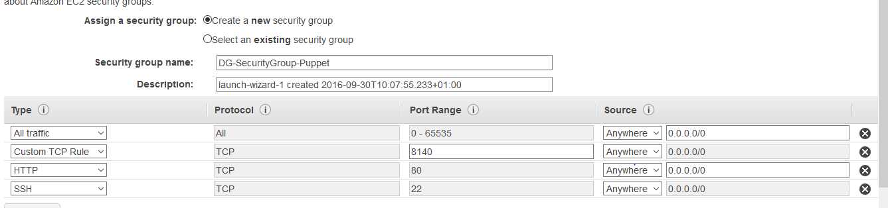
* Review and launch. You should be presented with a screen that has 3 instances. Rename them something appropriate, such as MasterDG, Agent1DG, Agent2DG etc. We’ll be setting up Puppet on these instances:

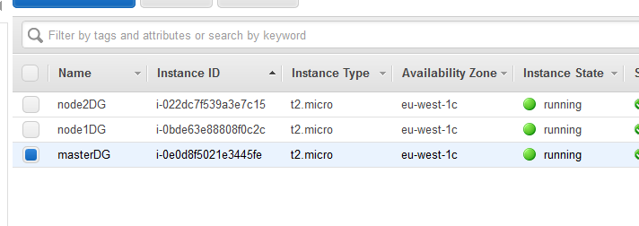

# Final Exercise

Find below a number of tasks to use Puppet in AWS machines.

* Create a new Linux machine on VirtualBox.
* Copy the .pem file you created in AWS to your Linux machine.
* Open 3 PuTTy clients on your local machine and SSH into your machine
* In the EC2 console, there should be instructions on how to SSH into your instances. Follow these instructions.
* Set up the Master/Agent Architecture on your 3 machines.
* Have one of your agents running Java, and the other running Git.
* Configure your master such that agents will retrieve configurations once every 20 mins.